## Steps to execute PS script for Application Configuration

#### **WCF Server**

**Table of Contents**

Initial Steps 1

Prerequisites 1

Steps to perform unit testing 2

output of application configuration automation  6

WCF Server Script Details 6

#### Initial steps :

* User must have access to AWS account.

#### Prerequisites: (we are installing it through powershell scripts)

**Following software should be installed:**

1. Redistributable
2. AWS CLI
3. SSM Agent
4. Cloudwatch Agent

**Two buckets should be created in S3:**

1. corecard-setup-files: where all the data of core card will be uploaded.
2. application-configuration-scripts: where all the PS scripts will be uploaded under WCF folder.
3. In **corecard-setup-files** there will be a folder of name **Prerequisites** which will contains all the prerequisites EXE & MSI files that needs to be installed.

**Steps to perform unit testing: (These steps should be performed for manual implementation)**

Step 1. Search EC2 & click on EC2 and then click on launch instance

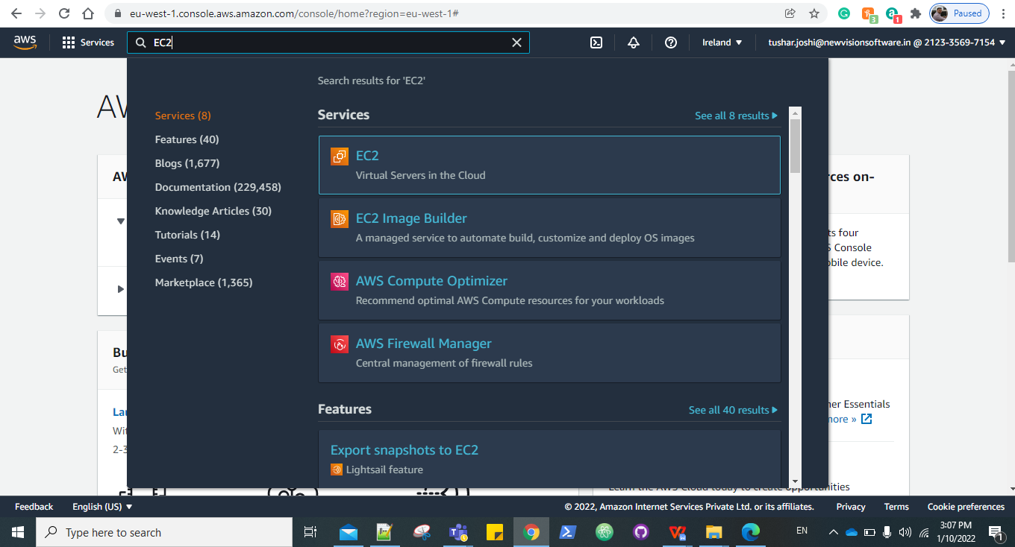

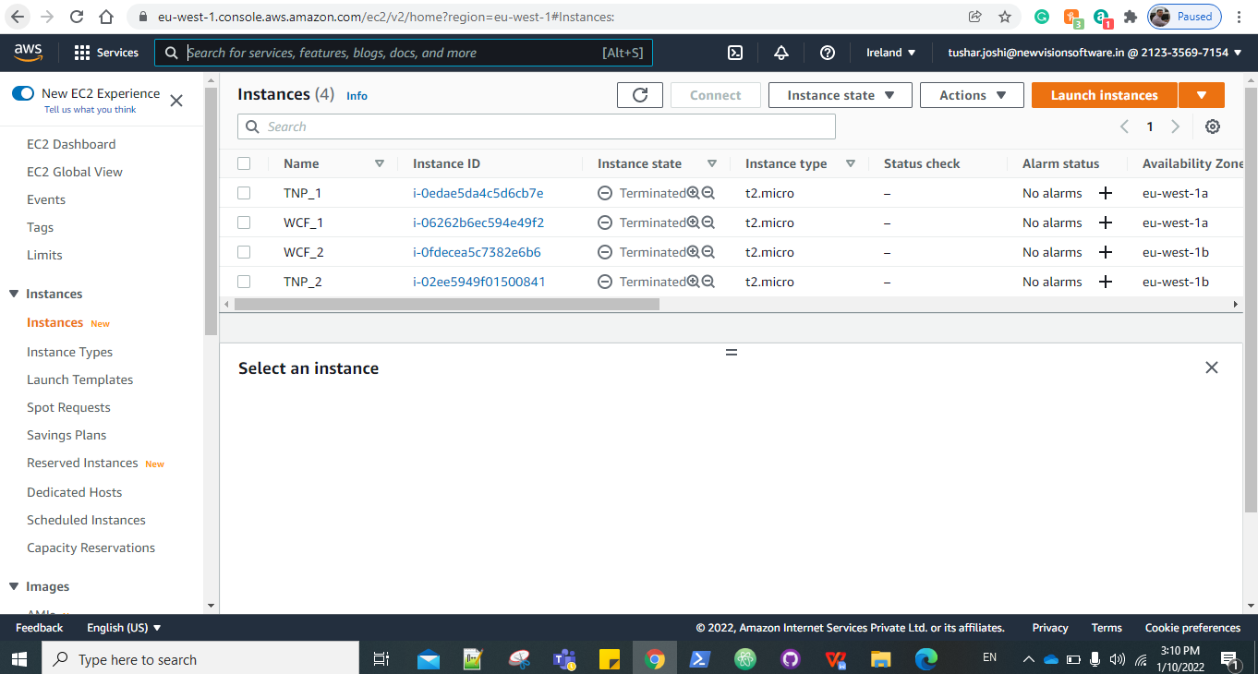

Step 2. Choose Amazon machine image

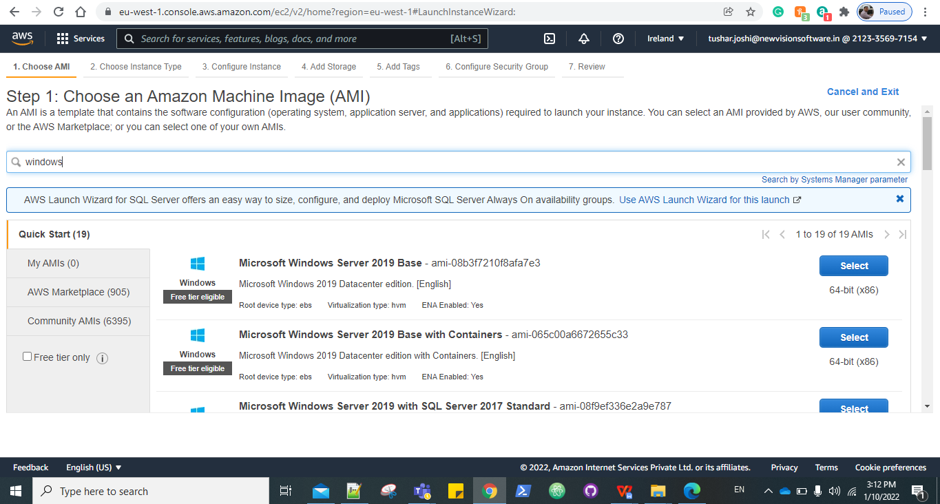

Step 3: Choose an Instance Type.

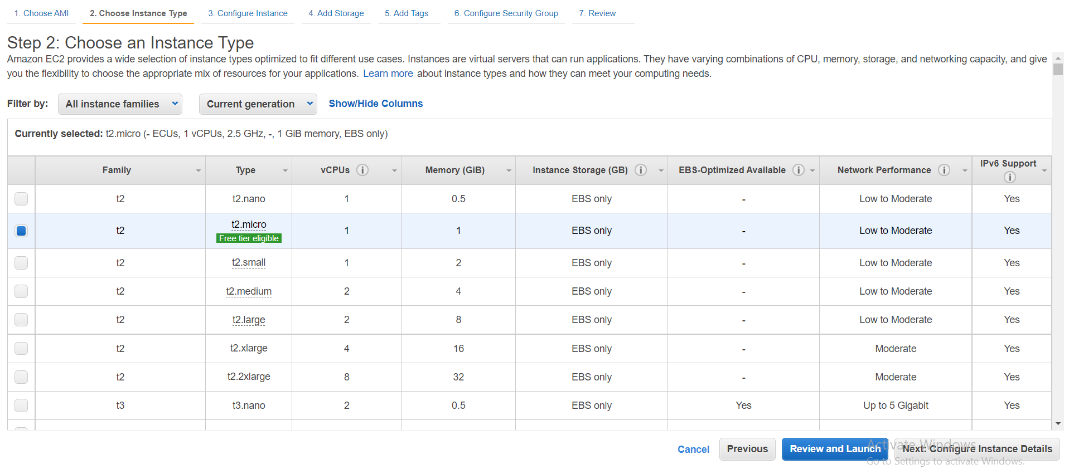

Step 4: In Configure Instance details select the no. of instances, AppServer_VPC, and in user data paste the following command:

|  |
| --- |
| **<powershell>**  **#For Application_Server**  **Initialize-AWSDefaultconfiguration -AccessKey <AccessKey> -SecretKey <SecretKey> -Region us-east-2 Copy-S3Object -BucketName application-configuration-scripts -KeyPrefix WCF -LocalFolder C:\ -Force**  **#Hit following command after successfully copying data from s3 bucket**  **Powershell.exe -File C:\Master.ps1 </powershell>** |

Note: Enter you AWS access key and secret key ID.

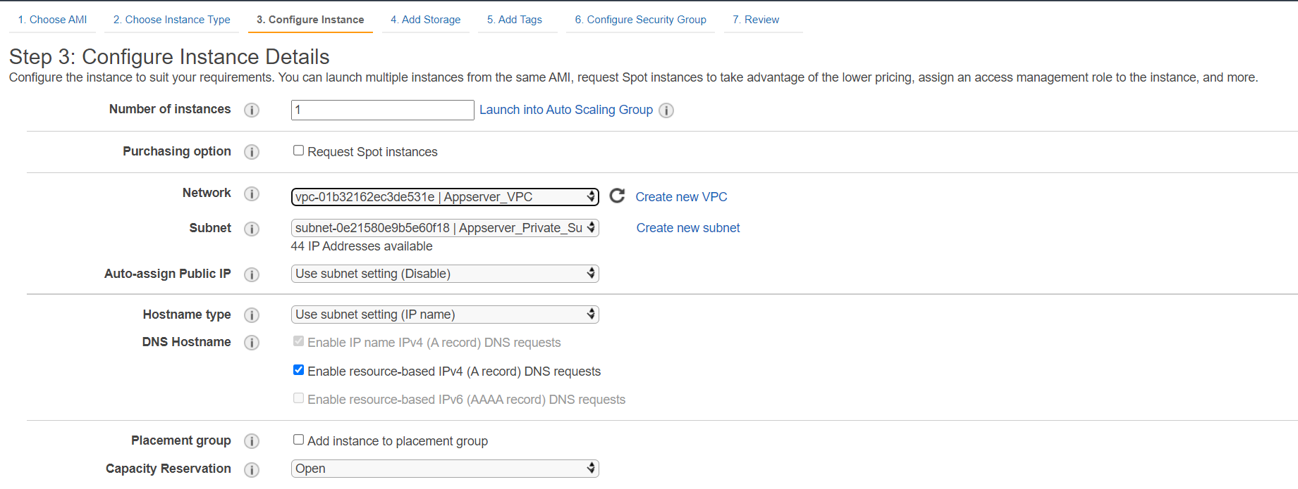

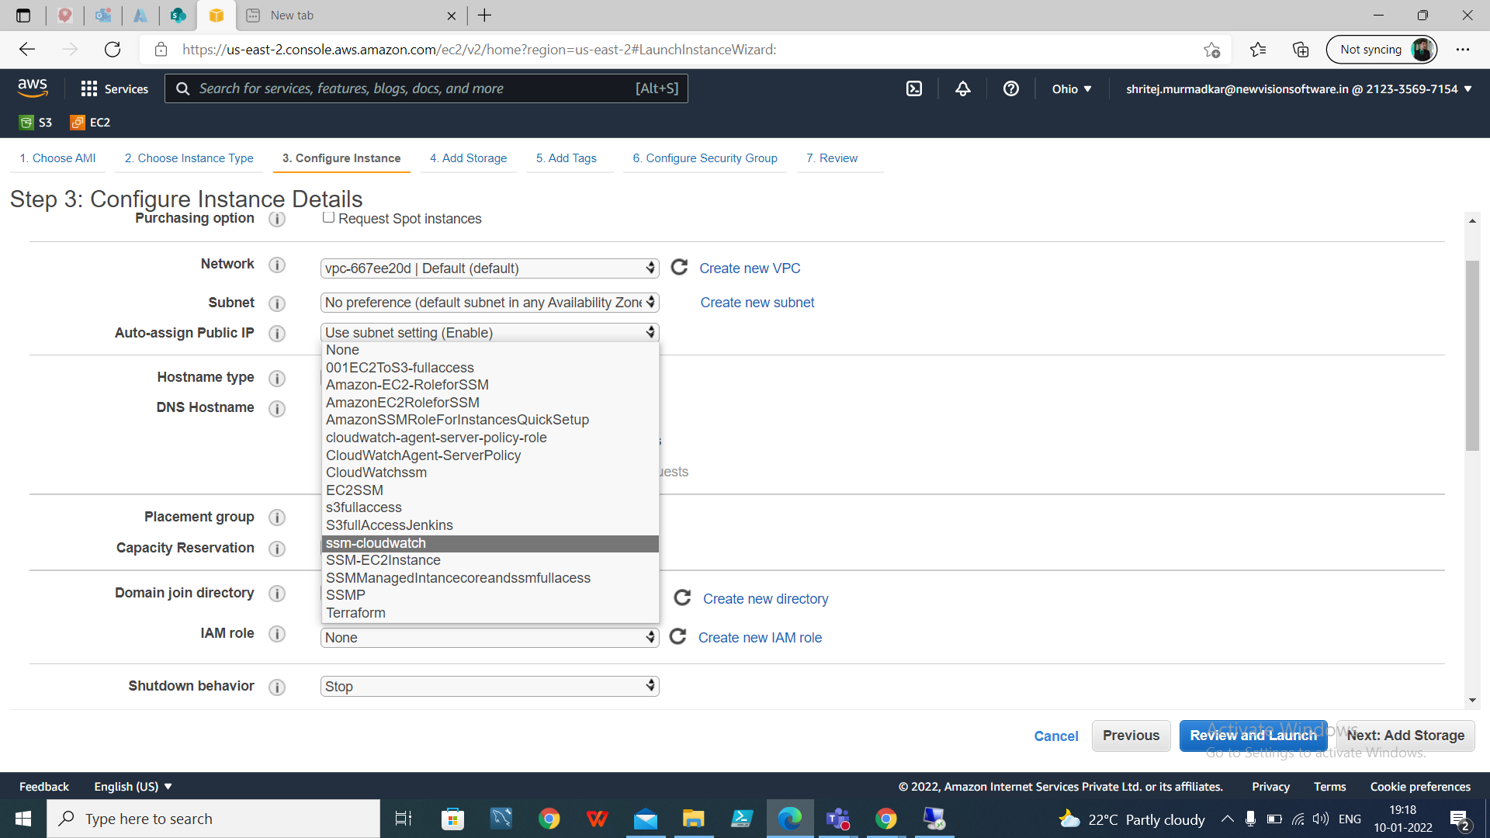

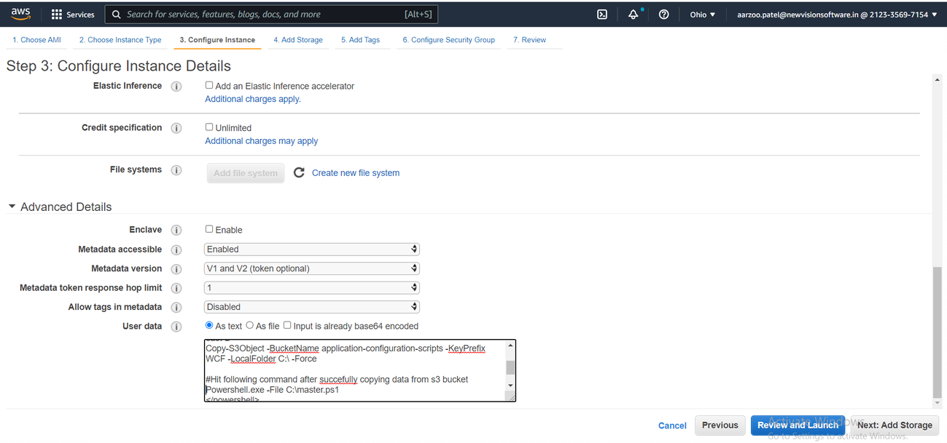

Step 5: Add storage.

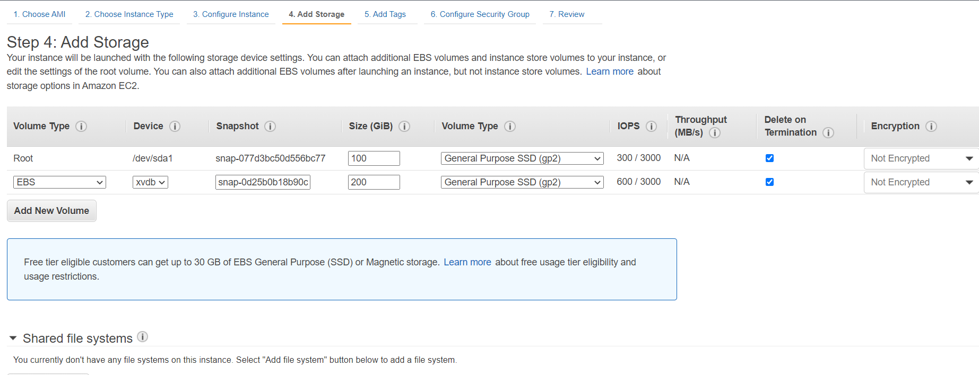

Step 6: Give the Tags if needed.

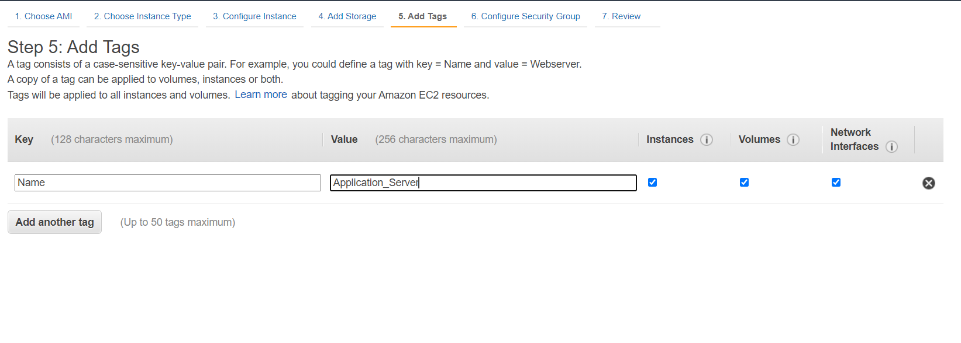

Step 7: Select the security group with name Appserver_sg.

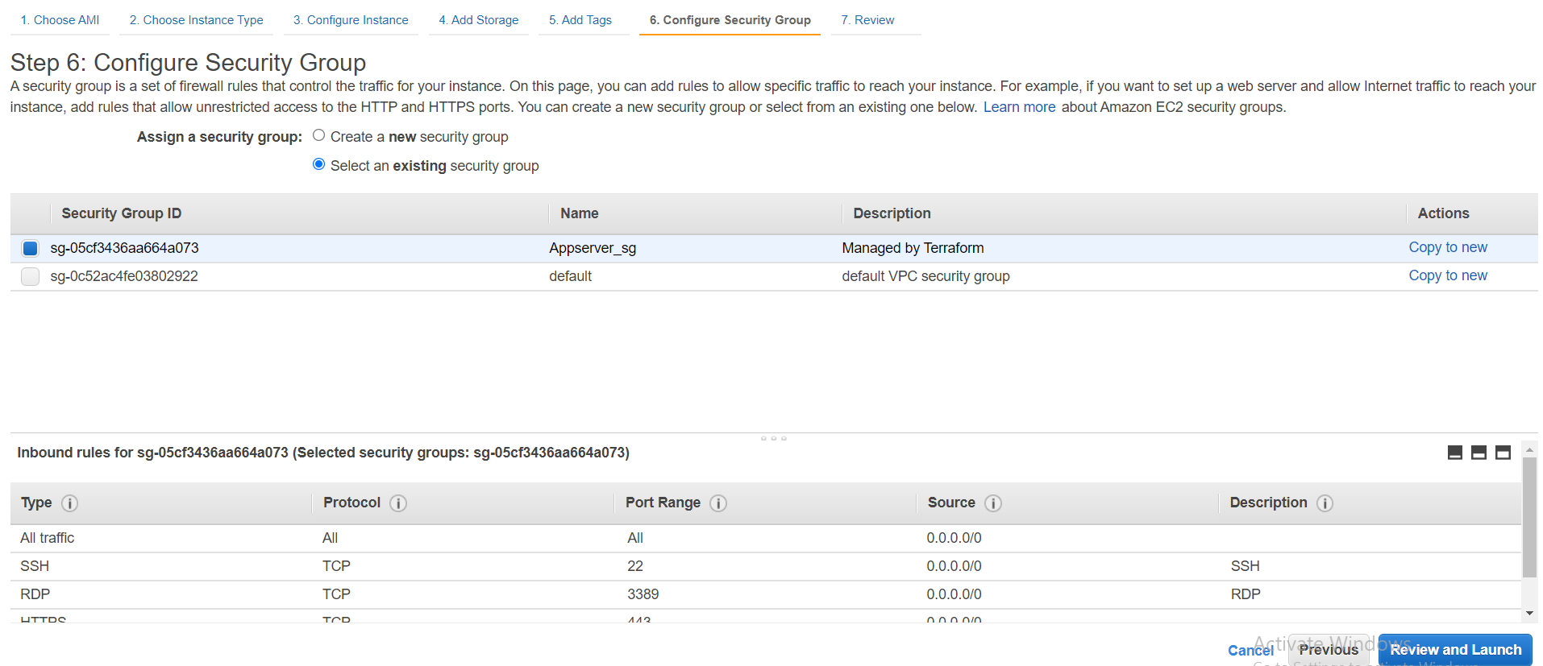

Step 8: Review and launch, Select the existing key pair or create new and launch.

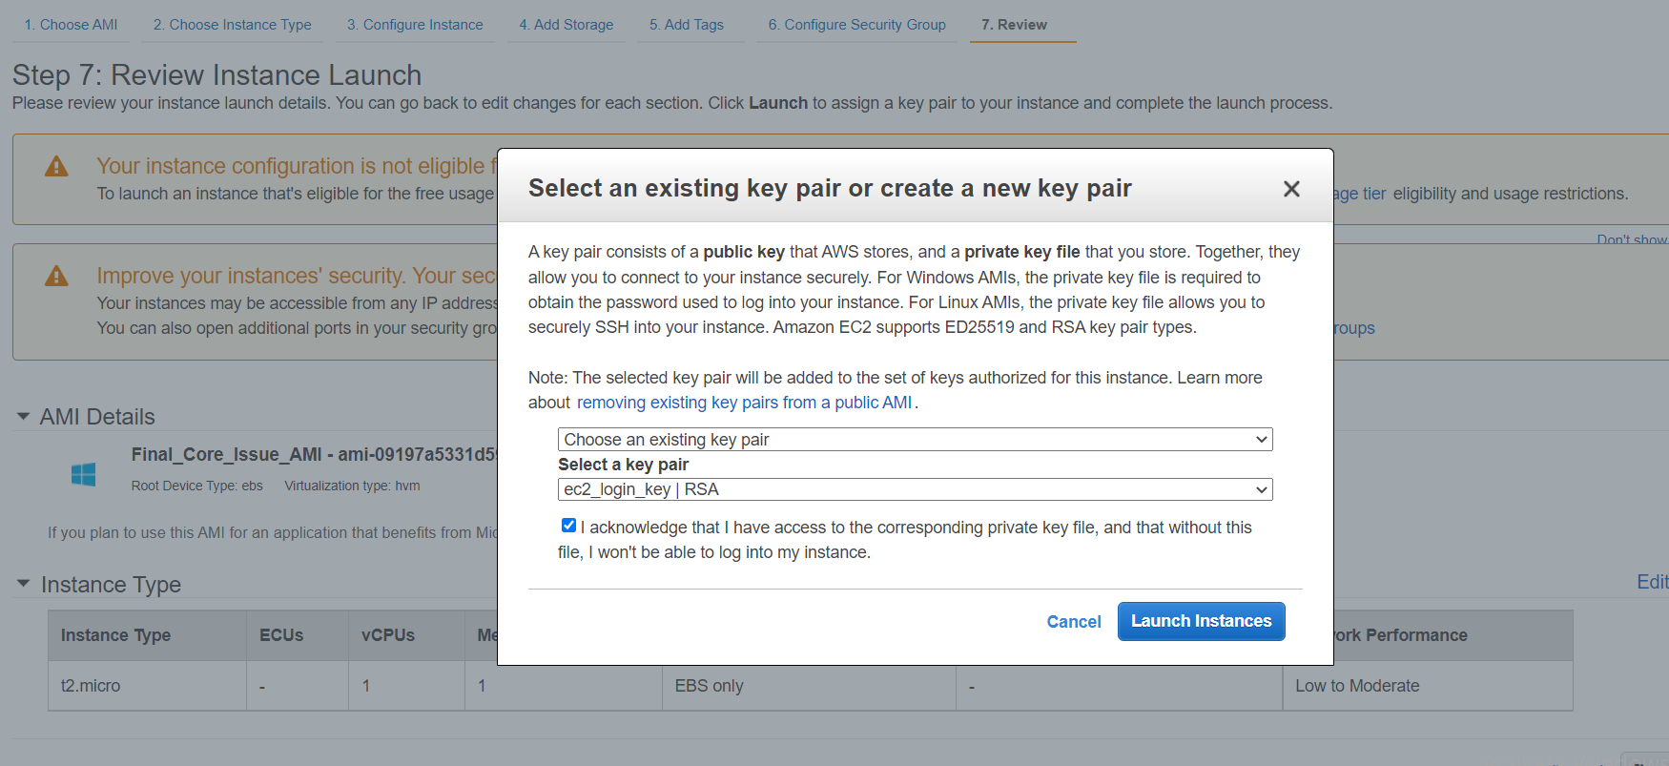

Step 9: It will take some time to configure the whole server and the scripts will be running in background.

#### **To see the output of application configuration automation:**

1. User should connect to bastion host.
2. Then, from bastion host user can connect to server through RDP.

#### **Application Server Script Details:**

In the S3 bucket all the files listed below are present:

**Note**: Please refer S3 bucket for updated files

1. **Administrator_password**: This script will set the password for user “Administrator”
2. **App_pool:** This script will create WCF apppool in application pool
3. **appSettings_Configuration:** This script file is used to import variables for each object of KMSDefaultMachines, dbbHandlerRoot, MailServer from path “C:\testvariable.xml “ and it will define the variables in lookuptable array.

Also it will check if the contents like $_.Key matching with $original_file.If it's matches then it will define the source path in $destination_file for those contents.

1. **Cleanup:** This script file is used to cleanup all related files from C & D drive. Once cleanup completed it will restart the machine.
2. **connectionStrings_corecardservices:** This script file is used to import variables for each object of CA_server_name, CA_DB_name, CI_server_name_corecardservices, CI_DB_name, CL_server_name_corecardservices, CL_DB_name from path “C:\testvariable.xml “ and it will define the variables in lookuptable array.

Also it will check if the contents like $_.Key matching with $original_file.If it's matches then it will define the source path in $destination_file for those contents.

1. **Core_card_services_app_pool_creation:** This script will create New-WebAppPool for CoreCard services
2. **corecardservices_website:** This script is used to import Module Webadministration details from IIS:\Sites\WebServer\CoreCardServices to physicalPath D:\WebServer\CoreCardServices and will create new website in IIS.
3. **Drive_Configuration:** This script is used to get the drive details where objects are raw, then it will initialize the disk and will create new partition with volume of NTFS filesystem
4. **install_prerequisites**: This script is used to install all prerequisites as below:
5. ZIP.EXE
6. AWS CLI
7. CLOUD WATCH AGENT
8. SSM AGENT
9. RedistributableT
10. **Log_path:** This script file is used to import variables for each object of Log_file_path from path “C:\testvariable.xml” and it will define the variables in lookuptable array.

And then it will check if the contents like $_.Key matching with $original_file.If it's matches then it will define the source in $destination_file for those contents.

1. **log4net_changes:** This script file is used to import variables for each object of log4net.Util.PatternString_filepath from path “C:\testvariable.xml” and it will define the variables in lookuptable array.

And then it will check if the contents like $_.Key matching with $original_file.If it's matches then it will define the source in $destination_file for those contents.

1. **master:** This is master script used to execute all power shell scripts to configure WCF server
2. **maxworker:** This script is used to set the maximum worker process value for WCF & CoreCardServices apppool.
3. **powershell_aws_commands:** This script will copy all the core card data from S3 bucket “corecard-setup-files”
4. **powershell_new_directories:** This script is used to create new directory & subdirectories for Webserver & Logs under D drive
5. **report_arr_exe:** This script is used to setup arr
6. **Setup_IIS:** This script is used to install IIS features through DeploymentConfigTemplateWCF.xml file
7. **siteBinding:** This script is used to Fetch the IPAddress from the Machine and arrange them in array Skipping the localhost and to Add the Certificate to the LocalMachine in personal store
8. **tls_script:** This script is used to configure IIS with SSL/TLS Deployment

20. **wcf_connectionStrings_configuration:** This script file is used to import variables for each object of WCF from path “C:\testvariable.xml “ and it will define the variables in lookuptable array.

Also it will check if the contents like $_.Key matching with $original_file.If it's matches then it will define the source path in $destination_file for those contents.

21. **wcf_website:**  This script is used to import module from

"IIS:\Sites\WebServer\WCF" to physicalPath "D:\WebServer\WCF" and will create WCF website in IIS.

1. **testvariable.xml:** In this xml file contains all the variables for all the servers, In this file the tag name will fetch all the variables for that specific environment Eg. <ENV>DEV</ENV>

It will consist all environment tag which will include all server tags.

Original file contains all the values which will be needed to set in destination file. for example CI_Server_Name is declared in wcf_connectionStrings_configuration.ps1 and it will set the value in destination file.

Original files are as below:

1. **appSettings.config**
2. **connectionStrings.config**
3. **log4net.config**
4. **wcf_connectionStrings.config**
5. **Web.config**